[CEN 323 ] Computer Organization & Assembly Language
Lab 3 Journal

Name : Bilal Aamir
Enrollment Number: 01-135232-016

Lab Deliverables (submission guideline)

Create a folder named after your enrollment number and add the following files:
  - Create a folder named YourRollNumber_Lab3 containing:
- .asm files of all tasks.
- Add the following to the lab journal.
  - Full-screen screenshots of code.
  - Full-screen screenshots of output.
  - Code text.

  - Zip the Folder and upload to LMS.

Lab Task

Task 1:
Code (TEXT):
.data

var1 db 4
var2 db 2
msg1 db "The result of addition is : $"
msg2 db "The result of the subtraction is : $"
space db 10,13,"$"

.code
main:
mov ax,@data
mov ds,ax

mov cl,var1
add cl,var2
add cl,48

LEA dx,msg1

mov ah,09h
int 21h

;message displayed
mov dl,cl

mov ah,02h
int 21h
;number displayed

LEA dx,space
mov ah,09h
int 21h

;space displayed

LEA dx,msg2
int 21h

;message displayed

mov cl,var1
sub cl,var2
add cl,48

mov dl,cl
mov ah,02h
int 21h

;number displayed

mov ah,4Ch
int 21h

end main

Screenshot (CODE):
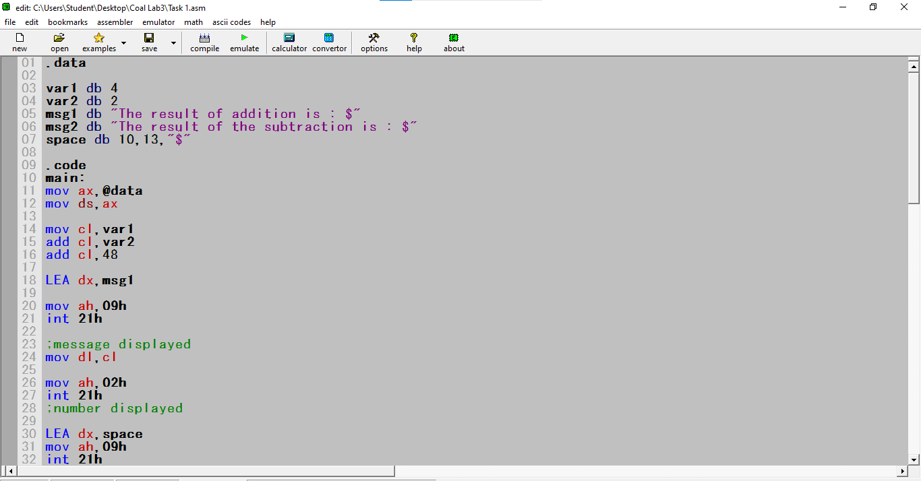

Screenshot (OUTPUT):
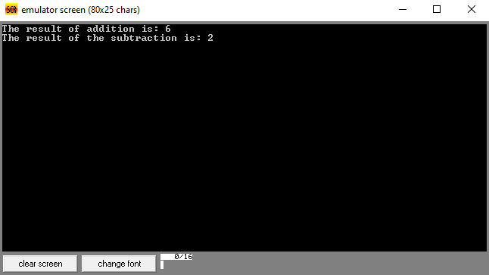

Task 2:
Code (TEXT):
.data

msg1 db "Enter the first Number : $"
msg2 db "Enter the second Number : $"
msg3 db "The result of multiplication is : $"
space db 10,13,"$"

num1 db ?
num2 db ?

.code
main:
mov ax,@data
mov ds,ax

LEA dx,msg1
mov ah,09h
int 21h
;displayed enter number 1 message

mov ah,01h
int 21h

mov num1,al
sub num1,48
; first number input

mov ah,09h
LEA dx,space
int 21h
;space

LEA dx,msg2
mov ah,09h
int 21h
;displayed enter number 2 message

mov ah,01h
int 21h

mov num2,al
sub num2,48
;second number input

mov ah,09h
LEA dx,space
int 21h
;space

LEA dx,msg3
mov ah,09h
int 21h
;displayed the multiplication message

mov al,num1
mul num2

mov dl,al
add dl,48

mov ah,02h
int 21h
;displayed result

mov ah,4Ch
int 21h

end main

Screenshot (CODE):
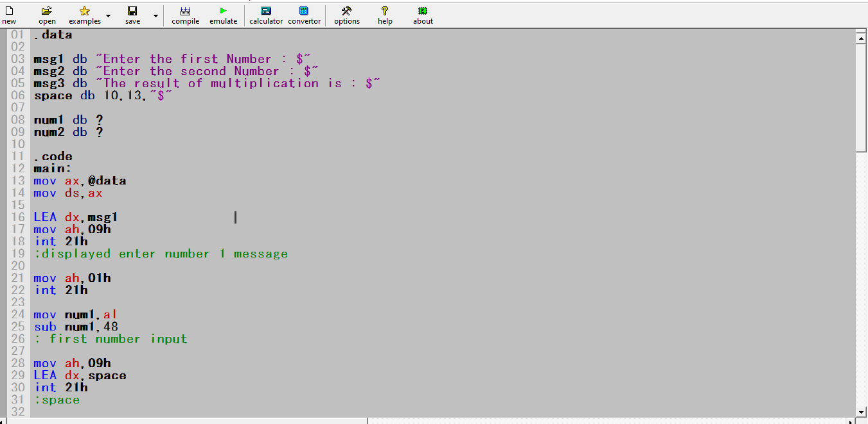

Screenshot (OUTPUT):
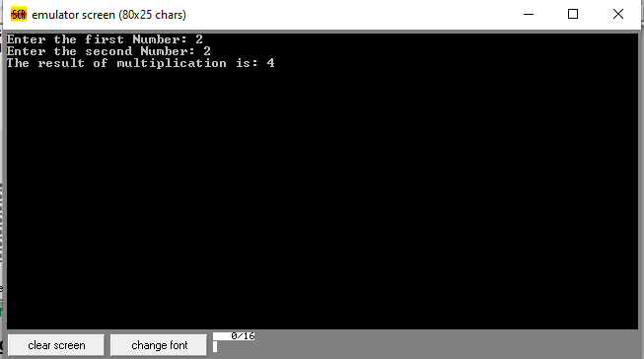

Task 3:
Code (TEXT):
.data

msg1 db "Enter the dividend : $"
msg2 db "Enter the divisor : $"
msg3 db "The remainder is : $"
msg4 db "The quotient is : $"
space db 10,13,"$"

dividend db ?
divisor db ?
quotient db ?
remainder db ?

.code
main:
mov ax,@data
mov ds,ax

LEA dx,msg1
mov ah,09h
int 21h

;displayed enter dividend

mov ah,01h
int 21h

mov dividend,al
sub dividend,48
;first number input

mov ah,09h
LEA dx,space
int 21h
;space

LEA dx,msg2
int 21h
;displayed enter divisor

mov ah,01h
int 21h

mov divisor,al
sub divisor,48
;first number input

xor ax,ax
mov al,dividend
div divisor
;division done

mov quotient,al
mov remainder,ah
;vaues stored

mov ah,09h
LEA dx,space
int 21h
;space

mov ah,09h
LEA dx,msg3
int 21h
;displayed remainder message

mov ah,02h
mov dl,remainder
add dl,48
int 21h
;displayed remainder

mov ah,09h
LEA dx,space
int 21h
;space

mov ah,09h
LEA dx,msg4
int 21h
;displayed quotient message

mov ah,02h
mov dl,quotient
add dl,48
int 21h
;displayed quotient

mov ah,4Ch
int 21h

end main
Screenshot (CODE):
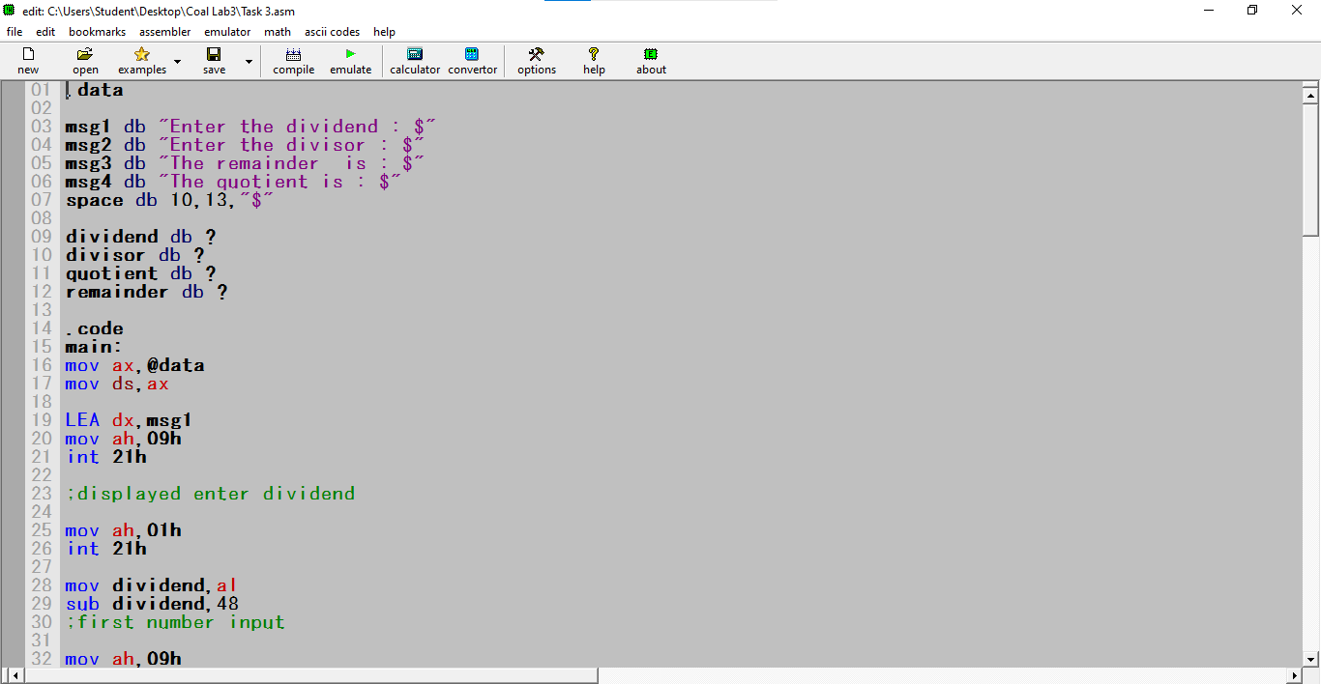

Screenshot (OUTPUT):
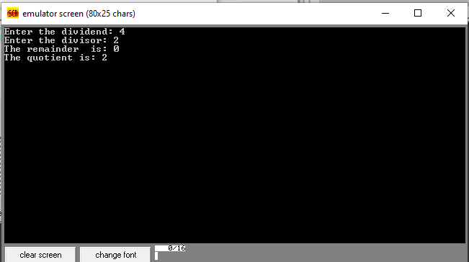

Task 4:
Code (TEXT):
.data

num dw 123
numm db ?
divisor db ?
num1 db ?
num2 db ?
num3 db ?

msg db "The number is : $"

.code
main:
mov ax,@data
mov ds,ax

mov ax,num
mov divisor,100
div divisor

mov numm,al
mov num1,ah

mov al,num1
mov ah,0
mov divisor,10
div divisor

mov num2,al
mov num3,ah

; Print Message
mov ah,09h
lea dx,msg
int 21h

mov ah,02h

mov dl,numm
add dl,48
int 21h

mov dl,num2
add dl,48
int 21h

mov dl,num3
add dl,48
int 21h

mov ah,4Ch
int 21h

end main

Screenshot (CODE):
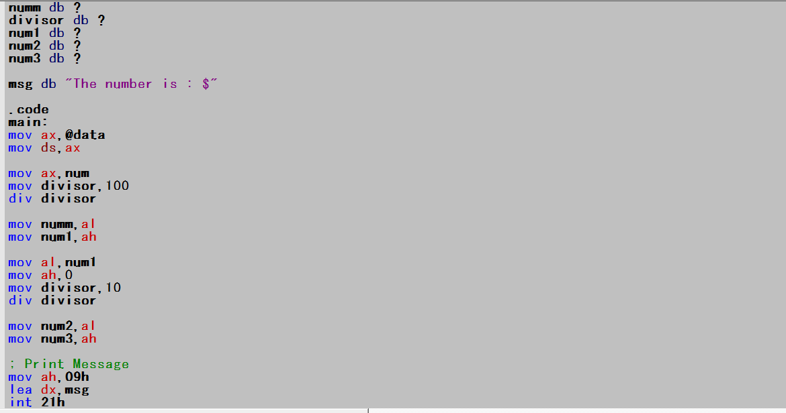

Screenshot (OUTPUT):
